final report
sbk002 and clopidogrel hydrogen sulfate raw material drug
dose formulations analyzed methodology validation assay
test facility
name： | Suzhou CTI Bio-Tech Co., Ltd.
Address: | Jiangsu Province Kunshan City New & Hi-tech Industrial Development Zone Yuanfeng Road No. 166
Telephone: | 0512-36801688
Sponsor
name： | Chengdu Shibeikang Biomedical Technology Co. Ltd
Address: | Chengdu New & Hi-tech Industrial Development Zone (Western District), 17 Xixin Avenue
Telephone: | 028-62532315
study start and end dates: 2018-12-03 ~ 2019-01-21

Signature Page

Li Ping Date
study director

He Yan Date
QA

Statement of GLP Compliance

GLP regulations:
All parts of this assay completed at Suzhou Huace Biological Technique Co., Ltd. (test facility) comply with the study protocol and the test facility's standard operating procedures (SOPs). This assay follows the Good Laboratory Practices (GLPs) for non-clinical medication studies.
1) "Good Laboratory Practices (GLPs) for Non-clinical Studies of Drugs" (Order No. 34) issued by China's National Food and Drug Administration (fCFDA) effective from September 1, 2017.
No known events occurred during the study process that could affect data integrity.

Li Ping Date
study director

QA Statement

Study director: Li Ping
test article code: sbk002
Study Name: Verification assay for analyzing methods of sbk002 and clopidogrel bisulfate raw material dose formulations
study number：A2018030-FA01

justification: The original Food and Pharmaceuticals Supervision and Management General Administration of China’s "Good Laboratory Practices (GLPs) for Medication Non-clinical Study" (Order No. 34), effective September 1, 2017, OECD Principles of Good Laboratory Practice (as revised in 1997) ENV/MC/CHEM(98)17, U.S. Food and Pharmaceuticals Supervision and Management Administration Good Laboratory Practice for Nonclinical Laboratory Studies (21 CFR Part 58), study protocol, and standard operating procedures (SOPs) examination, and provide examination reports to the study director and Test Facility Management dates. Furthermore, this statement confirms that the final report accurately reflects the raw data of the assay.
Inspection Contents | Inspection Date | reporting date (SD/Test Facility Management)
study protocol | 2018-12-01 | 2018-12-01
ANALYSIS AND TEST sample preparation | 2018-12-04 | 2018-12-04
Chromatographic analysis | 2018-12-04 | 2018-12-04
raw data | 2019-01-16 | 2019-01-16
final report | 2019-01-16 | 2019-01-16
In addition, the quality assurance department executes justification for SOP implementation through quarterly process examinations and annual institutional examinations.

special QA: He Yan
Signature: Date:

Contents
Signature Page 2
Statement of GLP Compliance 3
QA statement 4
TABLE OF CONTENTS 5
ABSTRACT 7
1. General Information 10
1.1. Study Name and Number 10
1.2. Study Objective 10
1.3. test facility 10
1.4. Sponsor 10
1.5. Study Personnel composition 10
1.6. Quality assurance personnel 11
1.7. assay key dates 11
1.8. Regulations and technical guidelines followed 11
2. Study Materials and methods 11
2.1. reference sample 11
2.2. test article 12
2.3. reference item 12
2.4. Major Instruments 13
2.5. Major Reagents 13
2.6. Related solution preparation 14
2.7. analyzed method 18
3. methodology verification 18
3.1 Methodology validation content Listing 7.7 18
4. Data acquisition and analysis 20
5. study protocol and amendments, deviation 20
6. result 20
6.1. System Suitability 20
6.2. Stock Solution Comparison 20
6.3. Quality Control 20
6.4. Specificity 20
6.5. Standard Curve linear range 21
6.6. Carry-over 21
6.7. lower limit of quantification 21
6.8. accuracy and precision 21
6.9. Dose formulations disposal post-stability 21
6.10. dose formulationsstability 21
7. Conclusion 22
8. Storage of Relevant Data 22
8.1. Archiving Time 22
8.2. Storage location and Storage condition 22
9. mainly reference literature 23
10. Appendixes 23
Appendix I: Appendix Tables 25
Appendix II: Appendix Figures 39
Appendix III: study protocol 48

ABSTRACT
Purpose: To validate the analyzed method for determining the concentration of the test article in Project A2018030, and to investigate the preparation method and stability of dose formulations, ensuring the quality and preparation accuracy of the test article. To provide reliable scientific reference for issues discovered in preclinical safety evaluations (such as the relationship between toxicity and dose).
method: Use an ultra-high performance liquid chromatograph to assess the concentration and stability of the dose formulations of the preparation. Testing performed at 220 nm wavelength with a UPLC® BEH C18 Chromatographic column and isocratic elution for sbk002 and Clopidogrel Hydrogen Sulfate (clo). Assessments include System Suitability, Stock Solution Comparison, quality control, specificity, Standard Curve linear range, Carry-over, lower limit of quantification, accuracy and precision, post-disposal stability of dose formulations, and stability validation of dose formulations.
result:
System Suitability (sbk002): the RSD of Peak Area is between 0.22 % ~ 0.50 %, the RSD of retention time is between 0.06 % ~ 0.08 %, and the tailing factor is between 1.17 ~ 1.39.
Stock Solution Comparison (sbk002): Ratio of Peak Area between Quality Control Sample QC and Standard Curve sample STD3 is between 96.71% ~ 100.76%.
Quality control (sbk002): The accuracy of Quality Control Sample QC is between 96.57% and 98.90%, with precision RSD at 0.48% and 0.50%.
Specificity: There are no interference peaks at the retention times of blank solvent and blank vehicle specificity samples for sbk002/clo.
Standard Curve linear range (sbk002): The regression coefficient (R2) of the Standard Curve is between 0.9964 ~ 0.9993, and the accuracy of each concentration of the Standard Curve is between 98.26 % ~ 103.30 %.
Carry-over (sbk002): The blank solvent sample has no interference peaks at sbk002 retention time.
lower limit of quantification (sbk002): The signal-to-noise ratio (S/N) is between 83 and 242, with accuracy between 100.70% and 102.06%, and precision RSD at 0.70%.
Accuracy and precision (sbk002): Accuracy between 89.53% ~ 104.95%, inter-assay precision RSD between 0.71% ~ 5.54%, intra-assay precision RSD is 4.25%.
stability of dose formulations after disposal (sbk002): the ratio of the testing concentration of the stability sample to the initial concentration is between 96.68 % ~ 99.88 %, the ratio of the testing concentration to the labeled concentration is between 100.38 % ~ 104.51 %, and RSD is 2.10 %.
Dose formulations stability (sbk002): Dose formulations room temperature light-protected stability for 2 h: The ratio of testing concentration to initial concentration in the stability sample ranges from 96.19% to 99.70%, the ratio of testing concentration to labeled concentration ranges from 100.65% to 102.21%, with RSD being 0.81%; Dose formulations room temperature light-protected stability for 4 h: The ratio of testing concentration to initial concentration in the stability sample ranges from 96.11% to 98.45%, the ratio of testing concentration to labeled concentration ranges from 100.87% to 102.42%, with RSD being 0.87%.
System Suitability (clo): The RSD of Peak Area is between 0.25% ~ 0.48%, the RSD of retention time is between 0.00% ~ 0.08%, and the tailing factor is between 1.32 ~ 1.45.
Stock Solution Comparison (clo): The ratio of the Quality Control Sample QC to the Standard Curve sample STD3 peak areas ranges from 99.65% to 100.02%.
Quality Control (clo): The accuracy of Quality Control Sample QC is between 98.39% and 99.61%, with precision RSD being 0.47% and 0.12%.
Standard Curve linear range (clo): The regression coefficient (R2) of the Standard Curve is between 0.9986 ~ 0.9998, and the accuracy of each concentration within the Standard Curve linear range is between 98.61% ~ 102.84%.
Carry-over (clo): No interference peaks are observed at the cloretention time in the blank solvent sample.
lower limit of quantification (clo): S/N ratio is between 35 ~ 138, accuracy is between 98.96 % ~ 100.38 %, precision RSD is 0.72 %.
accuracy and precision (clo): accuracy is between 98.65 % ~ 106.66 %, inter-assay precision RSD is between 1.23 % ~ 1.98 %, intra-assay precision RSD is 2.59 %.
Dose formulations disposal post-stability (clo): The testing concentration to initial concentration ratio of stability samples between 102.90 % ~ 105.99 %, testing concentration to labeled concentration ratio between 103.96 % ~ 104.56 %, RSD is 0.30 %.
dose formulations stability (clo): stability of the dose formulations at room temperature, protected from light, for 4 hours: The testing concentration ratio to the initial concentration is between 98.05% ~ 101.78%, and the testing concentration ratio to the labeled concentration is between 99.51% ~ 100.99%, with an RSD of 0.74%.
Conclusion: The analyzed method established in this assay for sbk002 and clo dose formulations has good linearity within the concentration range of 5.0 ~ 15.0 μg/mL. System Suitability, Stock Solution Comparison, Quality Control, Specificity, Carry-over, Lower Limit of Quantification, accuracy, and precision all meet the requirements for formulation analysis and testing. The sbk002 dose formulations (concentration: 250.0 mg/mL) show good stability for 4 hours at room temperature, protected from light. The dose formulations also remain stable for 1 day under similar conditions after disposal. The clo dose formulations (concentration: 250.0 mg/mL) show good stability for 4 hours at room temperature, protected from light. Stability is maintained for 1 day under similar conditions after disposal.

General Information
  - Study Name and number
Study Name: sbk002 and clopidogrel sulfate raw material dose formulations methodology validation assay;
study number：A2018030-FA01。
  - Study Objective
Perform validation of the analyzed method for determining test article concentration in the A2018030 project, and investigate the preparation method and stability of dose formulations to ensure the quality and preparation accuracy of the test article, providing reliable scientific reference for issues found in preclinical Safety Evaluation (such as the relationship between toxicity and dose).
  - test facility
Name: Suzhou Huace Bio-technology Co., Ltd.;
Address: No. 166, Yuanfeng Road, New & Hi-tech Industrial Development Zone, Kunshan City, Jiangsu Province;
Postal Code: 215300;
Contact person: Xia Yuye;
Telephone: 0512-36801688;
Fax: 0512-36802288;
email: xiayuye@cti-cert.com.
  - Sponsor
name：Chengdu Shibeikang Biomedical Technology Co. Ltd；
Address: 17 West Chip Avenue, Chengdu New & Hi-tech Industrial Development Zone (West Zone);
Postal code: 611731;
Contact person: Mu Xia;
Telephone: 028-62532315;
Email: 779061281@qq.com.
  - Study Personnel composition
    - study director
Name: Li Ping;
Address: No. 166, Yuanfeng Road, New & Hi-tech Industrial Development Zone, Kunshan City, Jiangsu Province;
Telephone: 0512-36801688;
Fax: 0512-36802288;
Email: liping@cti-cert.com.
    - Assay main personnel
Assay operators: Ding Weifang, Wang Xiaotong, Lu Mingmin;
Test article management: Chen Xiaoyan, Li Qi;
Preparation of test article: Shi Xinxin, Liu Lulu;
Data collation and statistical analysis: Li Ping, Wang Xiaotong, Zhao Qian.
  - quality assurance personnel
Name: He Yan;
Telephone: 0512-36801688;
email: cti-btc-qa.list@cti-cert.com.
  - assay key dates
assay start date: 2018-12-04;
Assay end date: 2018-12-06.
  - Followed regulations and technique guidelines
The regulations and technical guidelines this assay will follow include but are not limited to:
"Medication Non-clinical Study Good Laboratory Practices (GLPs)" (fCFDA, September 2017);
Nonclinical Safety Evaluation Test Article Testing Requirements Q&A (fCFDA, May 2014)
Pharmaceuticals Registration Management Measures (fCFDA, October 2007)
The implementation of this assay, unless specified otherwise in the plan, complied with the standard operating procedures of the testing facility (Standard Operating Procedures, SOPs).

Study Materials and Methods

  - Reference Standards
name: sbk002-D;
Characterization: off-white crystalline powder
Size: 2 g/bag;
content: 99.6%.
batch number: 180704;
Expiry date: 2020-08-07;
Storage condition: 15 ~ 25 ℃, airtight, dark, dry；
Manufacturer: Chengdu Shibeikang Biomedical Technology Co. Ltd;
Supplier: Chengdu Shibeikang Biomedical Technology Co. Ltd;
protection measures: Operate according to the "Occupational Health Safety and Protection Manual", wear suitable personal protective equipment (PPE);
Remaining reference item disposal: Return to the sponsor.
  - test article
Name/Code: sbk002;
Facility code：W2018027；
Characterization: off-white crystalline powder
Size: 51.8 g/bag;
content：99.8%；
batch number: 180802;
Expiry date: 2020-08-20 (tentative);
Storage condition: 15 ~ 25 ℃, airtight, dark, dry；
Manufacturer: Chengdu Shibeikang Biomedical Technology Co. Ltd;
Supplier: Chengdu Shibeikang Biomedical Technology Co. Ltd;
protection measures: Operate according to the "Occupational Health Safety and Protection Manual", wear suitable personal protective equipment (PPE);
Remaining Handing of test article: Return to the sponsor.
  - reference item
Name/Code: Clopidogrel Hydrogen Sulfate/clo;
Characterization: White crystalline powder;
Size: 38 g/bag;
Purity: 99.75 %;
batch number: 20171201;
Expiry date: 2019-11-30;
Storage condition: 15 ~ 25 ℃, airtight, dark, dry；
Manufacturer: Zhejiang Chehe Pharmaceutical Co., Ltd.;
Supplier: Chengdu Shibeikang Biomedical Technology Co. Ltd;
protection measures: Operate according to the "Occupational Health Safety and Protection Manual", wear suitable personal protective equipment (PPE);
Remaining Handing of test article: Return to the sponsor.
  - Major Instruments
name | Model | Manufacturer
Ultra-high-performance liquid chromatography (UHPLC) | ACQUITY UPLC H-Class | Waters
Digital display heated magnetic stirrer | MS-H280-Pro | Thermo Fisher
Magnetic stirrer | 84-1 (6) | Shanghai Meiyingpu Instrument Manufacturing Co., Ltd.
frozen centrifuge machine | 5418R | Eppendorf
Analyzed balance | XSE105DU | Mettler-Toledo
Electronic balance | ML4002/02 | Mettler-Toledo
Electronic balance | ML203/02 | Mettler-Toledo
Electronic balance | MS204TS/02 | Mettler-Toledo
Sonicate wave cleaner | SB-5200DT | Ningbo Xinzhiyu Biological Technology Co., Ltd.
pure water instrument | ELIX® Advantage 5 | Millipore
Single-channel adjustable pipette | 2 - 20 μL、10 - 100 μL  20 - 200 μL、30 - 300 μL  100 - 1000 μL | Eppendorf
  - Major Reagents
Reagent Name | Reagent Grade |  | Batch number | Manufacturer
Sterilized water for injection |  | / | M18080905-3 |  | Sichuan Kelun Pharmaceutical Co., Ltd.
Methanol |  | HPLC | 178511 |  | Fisher Scientific
Acetonitrile |  | HPLC | 184265 |  | Fisher Scientific
Trifluoroacetic acid / TFA |  | HPLC | I3980050 |  | CNW Technologies
sodium carboxymethyl cellulose/CMC-Na |  | USP grade | F1719015 |  | Aladdin
pure water |  | / | / |  | Suzhou CTI Bio-Tech Co., Ltd.
  - related solution preparation
Adjust the weighing amount and prepared volume of each solution according to actual needs and corresponding preparation ratios. Solutions without an indicated expiry date (except dose formulations) are used on the same day they are prepared. Define the date of first preparation of the standard curve sample as the first day (Day1/D1), and so on up to the nth day (Day n/Dn).
    - Preparation of mobile phase
Aqueous phase (0.2% TFA aqueous solution): Measure 1000 μL TFA and add to 500 mL sterilized water for injection, mix well, then sonicate to remove bubbles for 15 min, and it is ready. Store at room temperature, expiry date 3 days.
Organic phase (Acetonitrile): Acetonitrile, sonicate to degas for 15 min. Store at room temperature, expiry date 1 month.
    - Preparation of Diluent
Diluent 1 (Acetonitrile): Measure 400 mL Acetonitrile, then it is ready. Room temperature storage, expiry date 1 month.
Diluent 2 (40% Acetonitrile aqueous solution): Measure 400 mL Acetonitrile and add to 600 mL sterilized injection water, mix well, then it is ready. Room temperature storage, expiry date 1 month.
    - Standard Curve sample preparation
      - Preparation of Standard Curve sample for sbk002
Weigh 10.61 mg sbk002-D (content: 99.6%), dissolve it in Diluent 1 and dilute to volume to 10 mL to prepare a standard curve stock solution at a certain concentration (concentration = weighed amount × content/volume). Named as: 181204-ST1-sbk.
Aspirate 946 μL of the above stock solution (181204-ST1-sbk), dilute to volume to 10 mL with Diluent 2, obtaining a 100 μg/mL standard curve working solution, named: 181204-WS1-sbk.
Prepare Standard Curve sample using Diluent 2.
solution name | Aspirating solution | aspirated volume  （μL） | dilute to volume volume  （mL） | theoretical concentration (μg/mL)
LR_STD1_sbk | 181204-WS1-sbk | 250 | 5 | 5.0
LR_STD2_sbk | 181204-WS1-sbk | 400 | 5 | 8.0
LR_STD3_sbk | 181204-WS1-sbk | 500 | 5 | 10.0
LR_STD4_sbk | 181204-WS1-sbk | 600 | 5 | 12.0
LR_STD5_sbk | 181204-WS1-sbk | 750 | 5 | 15.0
      - clo Standard Curve sample preparation
Weigh 10.37 mg clo (Purity: 99.75%), dissolve in Diluent 1, and dilute to volume to 10 mL to prepare a stock solution of a certain concentration for the standard curve (concentration = weighed amount × purity / volume). Named: 181204-ST1-clo.
Aspirate 967 μL of the above stock solution (181204-ST1-clo), dilute to volume to 10 mL with Diluent 2, to obtain a working standard solution with a concentration of 100 μg/mL, named: 181204-WS1-clo.
Prepare Standard Curve sample using Diluent 2.
solution name | Aspirating solution | aspirated volume  （μL） | dilute to volume volume  （mL） | Theoretical concentration  （μg/mL）
LR_STD1_clo | 181204-WS1-clo | 250 | 5 | 5.0
LR_STD2_clo | 181204-WS1-clo | 400 | 5 | 8.0
LR_STD3_clo | 181204-WS1-clo | 500 | 5 | 10.0
LR_STD4_clo | 181204-WS1-clo | 600 | 5 | 12.0
LR_STD5_clo | 181204-WS1-clo | 750 | 5 | 15.0
    - Quality Control Sample preparation
      - sbk002 Quality Control Sample preparation
Weigh 10.38 mg sbk002-D (content: 99.6%), dissolve it in Diluent 1 and dilute to volume to 10 mL to prepare a quality control stock solution at a certain concentration (concentration = weighed amount × content/volume). Named as: 181204-ST2-sbk.
Aspirate 967 μL of the above stock solution (181204-ST2-sbk), dilute to volume with diluent to 10 mL, resulting in a 100 μg/mL quality control working solution, named: 181204-WS2-sbk.
Prepare Quality Control Sample with Diluent 2.
solution name | Aspirating solution | aspirated volume  （μL） | dilute to volume volume  （mL） | theoretical concentration (μg/mL)
SST_QC_sbk | 181204-WS2-sbk | 500 | 5 | 10.0
LOQ_QCL_sbk_1 | 181204-WS2-sbk | 250 | 5 | 5.0
LOQ_QCL_sbk_2 | 181204-WS2-sbk | 250 | 5 | 5.0
LOQ_QCL_sbk_3 | 181204-WS2-sbk | 250 | 5 | 5.0
      - clo Quality Control Sample preparation
Weigh 10.38 mg of clo (Purity: 99.75%), dissolve in diluent 1, and dilute to volume to 10 mL to prepare a quality control stock solution of a certain concentration (concentration = weighed amount × purity/volume). Named: 181204-ST2-clo.
aspirate 966 μL of the above stock solution (181204-ST2-clo), dilute to volume to 10 mL with diluent 2 to obtain a working solution with a concentration of 100 μg/mL for quality control, named: 181204-WS2-clo.
Prepare Quality Control Sample with Diluent 2.
solution name | Aspirating solution | aspirated volume  （μL） | dilute to volume volume  （mL） | theoretical concentration (μg/mL)
SST_QC_clo | 181204-WS2-clo | 500 | 5 | 10.0
LOQ_QCL_clo_1 | 181204-WS2-clo | 250 | 5 | 5.0
LOQ_QCL_clo_2 | 181204-WS2-clo | 250 | 5 | 5.0
LOQ_QCL_clo_3 | 181204-WS2-clo | 250 | 5 | 5.0
    - Preparation of vehicle (0.5% CMC-Na)
Preparation method: Accurately weigh a certain amount of CMC-Na powder, use a measuring cylinder to measure a certain volume of pure water, transfer to a beaker, evenly disperse the CMC-Na powder in the beaker, add a stirring rod, and use a magnetic stirrer to stir until complete dissolution to obtain a 0.5% CMC-Na solution.
preparation method: Accurately weigh 2.000 g of CMC-Na powder, measure 400 mL pure water with a graduated cylinder and transfer to a beaker, evenly disperse the CMC-Na powder in the beaker, add a stirring bar, and stir with a magnetic stirrer until completely dissolved, to obtain 0.5 % CMC-Na solution 400 mL. Store at room temperature, valid for 7 days.
    - specificity sample preparation
Use vehicle (0.5 % CMC-Na) to prepare the blank vehicle specificity sample: aspirate 400 μL vehicle, dilute to volume to 10 mL with diluent 1, centrifuge (10000 r/min, 5 min, 20 ℃), aspirate 20 μL supernatant, dilute to volume to 20 mL with diluent 2 to obtain the blank vehicle specificity sample, named: Select_V.
    - preparation of dose formulations
Preparation method: Accurately weigh the required amount of test article based on the dose formulations concentration and prepared volume calculations (sbk002 dose formulations concentration = weighed amount × content/volume; clo dose formulations concentration = weighed amount × purity/volume). In an environment protected from excessive light at room temperature, accurately weigh a certain amount of test article into a mortar, add an appropriate amount of 0.5% CMC-Na solution, grind thoroughly, then completely transfer to a volumetric container, and dilute to mark with 0.5% CMC-Na solution to obtain the desired concentration of dose formulations.
preparation method example: Taking preparation of 50 mL as an example.
group | dose formulations  Labeled concentration  （mg/mL） | Preparation method
sbk002 group | 250.0 | Accurately weigh 12.5251 g of sbk002 into a mortar, grind it fully with 0.5% CMC-Na solution, transfer completely to a volumetric container (50 mL), and use 0.5% CMC-Na solution to dilute to the mark, obtaining 250.0 mg/mL sbk002 dose formulations.
clo group | 250.0 | Accurately weigh 12.5313 g of clo into a mortar, grind thoroughly with 0.5% CMC-Na solution, then completely transfer to a volumetric container (50 mL), and dilute to mark with 0.5% CMC-Na solution to obtain a 250.0 mg/mL dose formulation of clo.
Preparation condition: room temperature, protected from excessive light environment.
Identification method: The dose formulations of sbk002 and clo groups were characterized using green and blue labels respectively, indicating study number, name, concentration, number, preparation date, preparer, and finished product number.
transport conditions: room temperature, dark.
    - dose formulations sampling and treatment method
sampling method: Before sampling, stir with a magnetic stirrer for 15 minutes or more at a certain speed, the speed should form a clear depression without creating vortices or a lot of bubbles. Take 2 samples each from the upper, middle, and lower layers of the dose formulations to be tested, and perform disposal according to the table below for all 6 samples.
Treatment method: According to the volume listed in the table, take the dose formulations to be tested. In the first step, dilute to volume with diluent 1, then centrifuge (10,000 r/min, 5 min, 20℃), take the supernatant, and perform the second step of dilution. In the second and third steps, dilute to volume with diluent 2, then analyze.
group | dose formulations  Labeled concentration  (mg/mL) | First step dilution (S1) |  |  |  | Second dilution (S2) |  |  |  | Third step dilution (S3) |  |  |  | Theoretical concentration  (μg/mL)
group | dose formulations  Labeled concentration  (mg/mL) | dose formulation (μL) |  | dilute to volume volume(mL) |  | S1  (μL) |  | dilute to volume volume(mL) |  | S2  (μL) |  | dilute to volume volume(mL)
sbk002 group (Group A) | 250.0 |  | 400 |  | 10 |  | 500 |  | 10 |  | 200 |  | 10 |  | 10.0
clo group  (Group B) | 250.0 |  | 400 |  | 10 |  | 500 |  | 10 |  | 200 |  | 10 |  | 10.0
Remaining sample disposal: After testing is qualified, the remaining dose formulations will be returned to the Test Article Management Department, and disposed of according to medication/chemical waste procedures.
    - preparation of other solutions
Wash (90% Methanol aqueous solution): Measure 900 mL Methanol and add to 100 mL sterilized injection water, sonicate to remove bubbles for 15 min, then it is ready. Room temperature storage, expiry date 1 month.
Purge Wash, Seal Wash (10 % Methanol aqueous solution): Measure 900 mL sterilized water for injection and add to 100 mL Methanol, then sonicate to remove bubbles for 15 min, and it is ready. Store at room temperature, expiry date 7 days.
  - Analyzed method
Ultra-high performance liquid chromatography: ACQUITY UPLC H-Class, Waters;
Chromatographic column: ACQUITY UPLC® BEH C18 1.7 μm 2.1 mm × 50 mm;
Testing wavelength: 220 nm
Column temperature: 35 ℃;
Injection tray temperature: OFF;
Injection volume: 1 μL;
Flow rate: 0.3 mL/min;
Run time: 3 min (sbk002 run time); 1.5 min (clo run time)
Isocratic elution, water phase: organic phase = 55:45;
Wash: sterilized water for injection : Methanol = 10 : 90
Purge Wash, Seal Wash: sterilized water for injection: Methanol = 90: 10.

methodology verification

3.1 Methodology validation content Listing 7.7

parameter | assay method | Acceptance criteria
System Suitability | Selection Quality Control Sample QC_X is used as the System Suitability sample. It is repeatedly determined six times before the analytical run to assess System Suitability, and a statistical analysis of these six values is performed. Named: SST_QC_X. | The RSD of Peak Area and retention time ≤ 2%.  Tailing factor (T): T ≤ 2.
Stock Solution Comparison | Selection Quality Control Sample QC_X and Standard Curve STD3_X as Stock Solution Comparison samples. Named: SSC_QC_X and SSC_STD3_X. | Ratio of Peak Area between 95% ~ 105%.
Specificity | Use Diluent 2 as the blank solvent sample, named: Select_S; use the vehicle preparation blank vehicle specificity sample, named: Select_V; use AP_A_1 and AP_B_1 as test article specificity samples, named: Select_sbk and Select_clo respectively. | Blank solvent and blank vehicle samples have no interference peaks or interfering peak areas ≤ 10% of the lower limit of quantification at the sbk002/clo retention time.
Standard Curve  linear range | Standard Curve linear range: 5.0 μg/mL ~ 15.0 μg/mL. With the concentration of the corresponding compound's Standard Curve as the horizontal coordinate and the Peak Area of the corresponding compound as the vertical coordinate, the linear regression equation is obtained. Named: LR_STD1_X ~ LR_STD5_X. | Regression coefficient (R2) ≥ 0.99, Standard Curve linear range each concentration back-calculated accuracy should be between 90 % ~ 110 %.
Carry-over | After running the upper limit quantification sample (STD5_X), run one blank solvent sample (dilution 2). Named: Carryover_X. | Blank solvent samples have no interference peaks or interfering peaks with Peak Area ≤ 10% of the lower limit of quantification Peak Area at the retention time of sbk002/clo.
Quality control | selection Quality Control Sample QC_X is uniformly distributed and repeatedly determined within the analytical run. Each is named: PCS_QC_X_n (n represents the nth determination within the analytical run). | Accuracy should be between 95% and 105%, precision RSD ≤ 5% (when n ≥ 3, RSD is required).
lower limit of quantification | Prepare 3 parallel QC samples (QCL_X) as the lower limit of quantification samples. Named: LOQ_QCL_X_1 ~ LOQ_QCL_X_3. | signal-to-noise ratio S/N ≥ 10, accuracy should be between 95% ~ 105%, RSD ≤ 5%.
Accuracy and precision | Conduct the analysis after sample preparation as per dose formulations, treating and injecting the sample. Repeat determination over three analytical runs on different days using the concentration of the batch's Standard Curve Calculation sample, calculating the method's accuracy and precision. Named: AP_A_1 ~ AP_A_6 and AP_B_1 ~ AP_B_6. | The accuracy of all groups should be between 85% ~ 115%, and the intra-assay precision RSD ≤ 10%.
dose formulations disposal stability | Run three samples from dose formulations preparation from the first analytical run for sbk002 and clo groups during the second analytical run, store at room temperature, protected from light for 1 day. Named: STA(Post)_A_1, STA(Post)_A_3, STA(Post)_A_5, STA(Post)_B_1 ~ STA(Post)_B_3, and STA(Post)_B_5. | The ratio of the testing concentration of stability samples from each group to the labeled concentration is between 85 % ~ 115 %, the ratio of the testing concentration to the initial concentration is between 90 % ~ 110 %, and stability sample RSD ≤ 10 %.
dose formulations  Stability | sbk002 dose formulations room temperature light-protected stability: Place the D1 preparation’s sbk002 group dose formulations at room temperature with light protection for 2 h and 4 h, then take one sample each from the top, middle, and bottom layers of the dose formulations. After performing disposal according to the dose formulations treatment method, analyze the samples. Named as: STA(Pre_2h)_A_1, STA(Pre_2h)_A_3, STA(Pre_2h)_A_5, STA(Pre_4h)_A_1, STA(Pre_4h)_A_3, and STA(Pre_4h)_A_5.  clo dose formulations room temperature, dark stability: After placing the clo dose formulations prepared by D1 at room temperature in the dark for 4 hours, take 1 sample each from the upper, middle, and lower layers of the dose formulations, dispose according to the dose formulations treatment method after disposal, and analyze by injection. Named: STA(Pre_4h)_B_1, STA(Pre_4h)_B_3, and STA(Pre_4h)_B_5. | The ratio of the testing concentration of stability samples from each group to the labeled concentration is between 85 % ~ 115 %, the ratio of the testing concentration to the initial concentration is between 90 % ~ 110 %, and stability sample RSD ≤ 10 %.
Note: “X” represents “sbk or clo”.

data acquisition and analysis
All raw data at the facility are manually collected according to the study protocol and the SOPs of Suzhou Huace Biological Technique Co., Ltd., and collected using the data acquisition system. Manually collected data is transcribed into Excel tables for analysis and reporting. The system for collecting and reporting electronic data is as follows:
System | Version | Purpose
Empower | 3 | UPLC testing concentration

Study protocol and amendments, deviation
Study protocols are detailed in Appendix 3. No protocol amendments or deviation records were generated in this assay.

result

  - System Suitability
Assay results see Appendix One Table 1-1 and Table 1-2. System Suitability (sbk002): The RSD of peak areas ranges from 0.22% to 0.50%, the RSD of retention times ranges from 0.06% to 0.08%, and the tailing factor ranges from 1.17 to 1.39; System Suitability (clo): The RSD of peak areas ranges from 0.25% to 0.48%, the RSD of retention times ranges from 0.00% to 0.08%, and the tailing factor ranges from 1.32 to 1.45.
  - Stock Solution Comparison
Assay result see Appendix I Tables 2-1 and 2-2. Stock Solution Comparison (sbk002): Ratio of Peak Area between Quality Control Sample QC and Standard Curve sample STD3 is between 96.71% ~ 100.76%; Stock Solution Comparison (clo): Ratio of Peak Area between Quality Control Sample QC and Standard Curve sample STD3 is between 99.65% ~ 100.02%.
  - Quality control
Assay result see Appendix I Tables 3-1 and 3-2. Quality control (sbk002): The accuracy of Quality Control Sample QC is between 96.57% ~ 98.90%, and the precision RSD is 0.48% and 0.50%; quality control (clo): the accuracy of Quality Control Sample QC is between 98.39% ~ 99.61%, and the precision RSD is 0.47% and 0.12%.
  - Specificity
Assay results see Appendix Two Figure 1. Specificity: Blank solvent and blank vehicle specificity samples have no interference peaks at the sbk002/clo retention time.
  - Standard Curve linear range
Assay results are in Appendix 1, Table 4-1, Table 4-2, and Appendix 2, Figures 2-1, 2-2. Standard Curve linear range (sbk002): The regression coefficient (R2) of the Standard Curve is between 0.9964 and 0.9993, with concentration accuracy between 98.26% and 103.30%. Standard Curve linear range (clo): The regression coefficient (R2) of the Standard Curve is between 0.9986 and 0.9998, with concentration accuracy between 98.61% and 102.84%.
  - Carry-over
Assay result see Appendix II Figures 3-1 and 3-2. Carry-over: There are no interference peaks at the retention time of sbk002/clo in blank solvent samples.
  - lower limit of quantification
Assay results can be found in Appendix 1, Tables 5-1 and 5-2. Lower limit of quantification (sbk002): Signal-to-noise ratio S/N is between 83 and 242, accuracy is between 100.70% and 102.06%, and precision RSD is 0.70%; lower limit of quantification (clo): Signal-to-noise ratio S/N is between 35 and 138, accuracy is between 98.96% and 100.38%, and density RSD is 0.72%.
  - accuracy and precision
assay results see Appendix I, Tables 6-1, 6-2, 7-1, and 7-2. accuracy and precision (sbk002): accuracy is between 89.53 % ~ 104.95 %, inter-assay precision RSD is between 0.71 % ~ 5.54 %, intra-assay precision RSD is 4.25 %; accuracy and precision (clo): accuracy is between 98.65 % ~ 106.66 %, inter-assay precision RSD is between 1.23 % ~ 1.98 %, intra-assay precision RSD is 2.59 %.
  - dose formulations disposal stability
Assay results see Appendix One Table 8-1 and Table 8-2. Dose formulations disposal post-room temperature light-protected stability for 1 day (sbk002): The ratio of the testing concentration to initial concentration in the stability sample ranges from 96.68% to 99.88%, the ratio of the testing concentration to labeled concentration ranges from 100.38% to 104.51%, with RSD being 2.10%; Dose formulations disposal post-room temperature light-protected stability for 1 day (clo): The ratio of the testing concentration to initial concentration in the stability sample ranges from 102.90% to 105.99%, the ratio of the testing concentration to labeled concentration ranges from 103.96% to 104.56%, with RSD being 0.30%.
  - dose formulations stability
Assay result see Appendix I Tables 9-1 and 9-2.
Dose formulations stability (sbk002): Dose formulations room temperature light-protected stability for 2 h: The ratio of testing concentration to initial concentration in the stability sample ranges from 96.19% to 99.70%, the ratio of testing concentration to labeled concentration ranges from 100.65% to 102.21%, with RSD being 0.81%; Dose formulations room temperature light-protected stability for 4 h: The ratio of testing concentration to initial concentration in the stability sample ranges from 96.11% to 98.45%, the ratio of testing concentration to labeled concentration ranges from 100.87% to 102.42%, with RSD being 0.87%.
dose formulations stability (clo): stability of the dose formulations at room temperature, protected from light, for 4 hours: The testing concentration ratio to the initial concentration is between 98.05% ~ 101.78%, and the testing concentration ratio to the labeled concentration is between 99.51% ~ 100.99%, with an RSD of 0.74%.

Conclusion
The sbk002 and clo dose formulations analyzed method established in this assay shows good linearity within the concentration range of 5.0 ~ 15.0 μg/mL. System Suitability, Stock Solution Comparison, quality control, specificity, Carry-over, lower limit of quantification, accuracy and precision all meet the formulation analysis requirements, and can be used for the ANALYSIS AND TEST of sbk002 and clo dose formulations. sbk002 dose formulations (concentration: 250.0 mg/mL) exhibit good stability within 4 h at room temperature with light protection, and after disposal exhibit good stability within 1 day at room temperature with light protection. clo dose formulations (concentration: 250.0 mg/mL) exhibit good stability within 4 h at room temperature with light protection, and after disposal exhibit good stability within 1 day at room temperature with light protection.

Storage of Relevant Data
  - Archiving Time
After the end of the assay, the study director will archive the assay data with the archives management department within 2 weeks after the conclusion of the study. Paper records should be stored for at least five years after the pharmaceuticals are marketed, and electronic files should be stored permanently.
  - Storage location and Storage condition
Storage location: Suzhou Huace Bio-technology Co., Ltd. Archives Management Department;
Storage condition: routine.
Contact person: Wu Li;
Contact Telephone: 0512-36801688.

mainly reference literature
[1] Whitmire ML, Bryan P, Henry TR, et al. Non Clinical Dose Formulation Analysis Method Validation and Sample Analysis [J]. AAPS J, 2010, 12 (4): 628-634.
[2] Gu Liqiang, Xin Yanfei, Gao Haiyan, Li Feng, et al. Discussion on issues related to the analysis of test articles by GLP institutions [J]. Journal of Toxicology, 2012, 26(5): 388-390.
[3] Meng Xiang, Li Ying, Pan Qi, Jiang Juan, et al. The significance and standardized requirements of test article testing in GLP studies [J]. Journal of Toxicology, 2011, 25(6): 471-473.
[4] Li Yaoting, Liang Jinqiang, Huang Zhiying. Testing and analysis of test articles in medication safety evaluation studies [J]. Medication Evaluation Studies, 2014, 37(6): 541-543.
[5] Su Min, Wang Jingkun. Issues related to non-clinical safety evaluation of test articles affect medication [J]. China Pharmaceuticals, 2015, 29(2): 141-146.

Appendixes
Appendix I: Appendix Tables
Table 1-1 System Suitability (sbk002)
Table 1-2 System Suitability (clo)
Table 2-1 Stock Solution Comparison (sbk002)
Table 2-2 Stock Solution Comparison (clo)
Table 3-1 Quality control (sbk002)
Table 3-2 Quality Control (clo)
Table 4-1 Standard Curve linear range (sbk002)
Table 4-2 Standard Curve linear range (clo)
Table 5-1 Lower limit of quantification (sbk002)
Table 5-2 lower limit of quantification (clo)
Table 6-1 Accuracy (sbk002)
Table 6-2 accuracy (clo)
Table 7-1 Precision (sbk002)
Table 7-2 precision (clo)
Table 8-1 dose formulations stability after disposal (sbk002)
Table 8-2 Dose formulations stability after disposal (clo)
Table 9-1 Dose formulations stability (sbk002)
Table 9-2 Dose formulations stability (clo)
Appendix 2: Appendix Figures
Figure 1 Specificity
Figure 2-1 Standard Curve linear range (sbk002)
Figure 2-2 Standard Curve linear range (clo)
Figure 3-1 Carry-over (sbk002)
Figure 3-2 Carry-over (clo)
Appendix Three: study protocol

Appendix I: Appendix Tables
Study Name: Verification assay for analyzing methods of sbk002 and clopidogrel bisulfate raw material dose formulations
Study number: A2018030-FA01 Table 1-1 System Suitability (sbk002)
date | name | Peak Area (Area) | retention time  (min) | Tailing factor (T)
2018-12-04 | SST_QC_sbk | 111433 | 1.431 | 1.37
2018-12-04 | SST_QC_sbk | 112185 | 1.434 | 1.38
2018-12-04 | SST_QC_sbk | 111546 | 1.432 | 1.36
2018-12-04 | SST_QC_sbk | 111657 | 1.432 | 1.37
2018-12-04 | SST_QC_sbk | 110548 | 1.433 | 1.37
2018-12-04 | SST_QC_sbk | 111020 | 1.431 | 1.37
2018-12-04 | Mean | 111398 | 1.432
2018-12-04 | SD | 561 | 0.001
2018-12-04 | RSD(%) | 0.50 | 0.08
2018-12-05 | SST_QC_sbk | 109758 | 1.439 | 1.37
2018-12-05 | SST_QC_sbk | 109443 | 1.439 | 1.39
2018-12-05 | SST_QC_sbk | 109119 | 1.442 | 1.37
2018-12-05 | SST_QC_sbk | 109283 | 1.440 | 1.39
2018-12-05 | SST_QC_sbk | 109840 | 1.439 | 1.39
2018-12-05 | SST_QC_sbk | 108471 | 1.440 | 1.37
2018-12-05 | Mean | 109319 | 1.440
2018-12-05 | SD | 498 | 0.001
2018-12-05 | RSD(%) | 0.46 | 0.08
2018-12-06 | SST_QC_sbk | 110170 | 1.493 | 1.17
2018-12-06 | SST_QC_sbk | 110348 | 1.493 | 1.17
2018-12-06 | SST_QC_sbk | 110465 | 1.493 | 1.17
2018-12-06 | SST_QC_sbk | 110746 | 1.493 | 1.17
2018-12-06 | SST_QC_sbk | 110642 | 1.495 | 1.18
2018-12-06 | SST_QC_sbk | 110169 | 1.494 | 1.17
2018-12-06 | Mean | 110423 | 1.494
2018-12-06 | SD | 240 | 0.001
2018-12-06 | RSD(%) | 0.22 | 0.06

Table 1-2 System Suitability (clo)
date | name | Peak Area (Area) | retention time  (min) | Tailing factor (T)
2018-12-04 | SST_QC_clo | 55760 | 0.764 | 1.44
2018-12-04 | SST_QC_clo | 55863 | 0.764 | 1.43
2018-12-04 | SST_QC_clo | 55592 | 0.765 | 1.44
2018-12-04 | SST_QC_clo | 55550 | 0.763 | 1.43
2018-12-04 | SST_QC_clo | 55807 | 0.764 | 1.44
2018-12-04 | SST_QC_clo | 55329 | 0.764 | 1.43
2018-12-04 | Mean | 55650 | 0.764
2018-12-04 | SD | 199 | 0.001
2018-12-04 | RSD(%) | 0.36 | 0.08
2018-12-05 | SST_QC_clo | 55286 | 0.764 | 1.44
2018-12-05 | SST_QC_clo | 55693 | 0.764 | 1.45
2018-12-05 | SST_QC_clo | 55034 | 0.764 | 1.45
2018-12-05 | SST_QC_clo | 55411 | 0.764 | 1.44
2018-12-05 | SST_QC_clo | 54978 | 0.764 | 1.44
2018-12-05 | SST_QC_clo | 55150 | 0.764 | 1.44
2018-12-05 | Mean | 55259 | 0.764
2018-12-05 | SD | 266 | 0.000
2018-12-05 | RSD(%) | 0.48 | 0.00
2018-12-06 | SST_QC_clo | 55062 | 0.797 | 1.32
2018-12-06 | SST_QC_clo | 55093 | 0.796 | 1.32
2018-12-06 | SST_QC_clo | 54780 | 0.796 | 1.33
2018-12-06 | SST_QC_clo | 54808 | 0.797 | 1.32
2018-12-06 | SST_QC_clo | 54837 | 0.797 | 1.33
2018-12-06 | SST_QC_clo | 54859 | 0.797 | 1.32
2018-12-06 | Mean | 54907 | 0.797
2018-12-06 | SD | 135 | 0.001
2018-12-06 | RSD(%) | 0.25 | 0.06

Table 2-1 Stock Solution Comparison (sbk002)
date | SSC_QC_sbk Peak Area(A1) | SSC_STD3_sbk Peak Area(A2) | A1/A2(%)
2018-12-04 | 112215 | 111369 | 100.76
2018-12-05 | 108072 | 111750 | 96.71
2018-12-06 | 110053 | 111240 | 98.93

Table 2-2 Stock Solution Comparison (clo)
date | SSC_QC_clo Peak Area(A1) | SSC_STD3_clo Peak Area(A2) | A1/A2(%)
2018-12-04 | 55775 | 55763 | 100.02
2018-12-05 | 54945 | 55137 | 99.65
2018-12-06 | 54765 | 54952 | 99.66

Table 3-1 Quality Control (sbk002)
date | name | theoretical concentration (μg/mL) | Measured concentration (μg/mL) | accuracy (%)
2018-12-04 | PCS_QC_sbk_1 | 10.0 | 9.890 | 98.90
2018-12-04 | PCS_QC_sbk_2 | 10.0 | 9.830 | 98.30
2018-12-04 | PCS_QC_sbk_3 | 10.0 | 9.773 | 97.73
2018-12-04 | PCS_QC_sbk_4 | 10.0 | 9.776 | 97.76
2018-12-04 | PCS_QC_sbk_5 | 10.0 | 9.845 | 98.45
2018-12-04 | PCS_QC_sbk_6 | 10.0 | 9.784 | 97.84
2018-12-04 | Mean |  | 9.816
2018-12-04 | SD |  | 0.047
2018-12-04 | RSD(%) |  | 0.48
2018-12-05 | PCS_QC_sbk_1 | 10.0 | 9.699 | 96.99
2018-12-05 | PCS_QC_sbk_2 | 10.0 | 9.657 | 96.57
2018-12-05 | PCS_QC_sbk_3 | 10.0 | 9.753 | 97.53
2018-12-05 | Mean |  | 9.703
2018-12-05 | SD |  | 0.048
2018-12-05 | RSD(%) |  | 0.50
2018-12-06 | PCS_QC_sbk_1 | 10.0 | 9.840 | 98.40
2018-12-06 | PCS_QC_sbk_2 | 10.0 | 9.824 | 98.24
Table 3-2 Quality Control (clo)
date | name | theoretical concentration (μg/mL) | Measured concentration (μg/mL) | accuracy (%)
2018-12-04 | PCS_QC_clo_1 | 10.0 | 9.870 | 98.70
2018-12-04 | PCS_QC_clo_2 | 10.0 | 9.866 | 98.66
2018-12-04 | PCS_QC_clo_3 | 10.0 | 9.867 | 98.67
2018-12-04 | PCS_QC_clo_4 | 10.0 | 9.961 | 99.61
2018-12-04 | Mean |  | 9.891
2018-12-04 | SD |  | 0.047
2018-12-04 | RSD(%) |  | 0.47
2018-12-05 | PCS_QC_clo_1 | 10.0 | 9.899 | 98.99
2018-12-05 | PCS_QC_clo_2 | 10.0 | 9.920 | 99.20
2018-12-05 | PCS_QC_clo_3 | 10.0 | 9.901 | 99.01
2018-12-05 | Mean |  | 9.907
2018-12-05 | SD |  | 0.012
2018-12-05 | RSD(%) |  | 0.12
2018-12-06 | PCS_QC_clo_1 | 10.0 | 9.839 | 98.39
2018-12-06 | PCS_QC_clo_2 | 10.0 | 9.842 | 98.42

Table 4-1 Standard Curve linear range (sbk002)
date | name | theoretical concentration (μg/mL) | Measured concentration (μg/mL) | accuracy (%) | R²
2018-12-04 | LR_STD1_sbk | 5.0 | 5.047 | 100.94 | 0.9993
2018-12-04 | LR_STD2_sbk | 8.0 | 8.066 | 100.83 | 0.9993
2018-12-04 | LR_STD3_sbk | 10.0 | 9.838 | 98.38 | 0.9993
2018-12-04 | LR_STD4_sbk | 12.0 | 11.957 | 99.64 | 0.9993
2018-12-04 | LR_STD5_sbk | 15.0 | 15.091 | 100.61 | 0.9993
2018-12-04 | Linear equation | Y = 1.15e+004 X - 1.87e+003
2018-12-05 | LR_STD1_sbk | 5.0 | 4.943 | 98.86 | 0.9976
2018-12-05 | LR_STD2_sbk | 8.0 | 8.264 | 103.30 | 0.9976
2018-12-05 | LR_STD3_sbk | 10.0 | 9.841 | 98.41 | 0.9976
2018-12-05 | LR_STD4_sbk | 12.0 | 11.837 | 98.64 | 0.9976
2018-12-05 | LR_STD5_sbk | 15.0 | 15.114 | 100.76 | 0.9976
2018-12-05 | Linear equation | Y = 1.13e+004 X - 3.32e+003
2018-12-06 | LR_STD1_sbk | 5.0 | 5.042 | 100.84 | 0.9964
2018-12-06 | LR_STD2_sbk | 8.0 | 7.861 | 98.26 | 0.9964
2018-12-06 | LR_STD3_sbk | 10.0 | 9.882 | 98.82 | 0.9964
2018-12-06 | LR_STD4_sbk | 12.0 | 12.381 | 103.18 | 0.9964
2018-12-06 | LR_STD5_sbk | 15.0 | 14.834 | 98.89 | 0.9964
2018-12-06 | Linear equation | Y = 1.15e+004 X - 3.11e+003
Table 4-2 Standard Curve linear range (clo)
date | name | theoretical concentration (μg/mL) | Measured concentration (μg/mL) | accuracy (%) | R²
2018-12-04 | LR_STD1_clo | 5.0 | 5.142 | 102.84 | 0.9986
2018-12-04 | LR_STD2_clo | 8.0 | 7.889 | 98.61 | 0.9986
2018-12-04 | LR_STD3_clo | 10.0 | 9.958 | 99.58 | 0.9986
2018-12-04 | LR_STD4_clo | 12.0 | 11.854 | 98.78 | 0.9986
2018-12-04 | LR_STD5_clo | 15.0 | 15.156 | 101.04 | 0.9986
2018-12-04 | Linear equation | Y = 5.68e+003 X - 2.11e+002
2018-12-05 | LR_STD1_clo | 5.0 | 5.027 | 100.54 | 0.9998
2018-12-05 | LR_STD2_clo | 8.0 | 7.944 | 99.30 | 0.9998
2018-12-05 | LR_STD3_clo | 10.0 | 9.984 | 99.84 | 0.9998
2018-12-05 | LR_STD4_clo | 12.0 | 12.069 | 100.58 | 0.9998
2018-12-05 | LR_STD5_clo | 15.0 | 14.977 | 99.85 | 0.9998
2018-12-05 | Linear equation | Y = 5.59e+003 X - 3.99e+002
2018-12-06 | LR_STD1_clo | 5.0 | 5.075 | 101.50 | 0.9996
2018-12-06 | LR_STD2_clo | 8.0 | 7.960 | 99.50 | 0.9996
2018-12-06 | LR_STD3_clo | 10.0 | 9.878 | 98.78 | 0.9996
2018-12-06 | LR_STD4_clo | 12.0 | 12.047 | 100.39 | 0.9996
2018-12-06 | LR_STD5_clo | 15.0 | 15.040 | 100.27 | 0.9996
2018-12-06 | Linear equation | Y = 5.58e+003 X - 1.81e+002
Table 5-1 Lower limit of quantification (sbk002)
date | name | theoretical concentration (μg/mL) | Measured concentration (μg/mL) | accuracy (%) | S/N
2018-12-04 | LOQ_QCL_sbk_1 | 5.0 | 5.035 | 100.70 | 242
2018-12-04 | LOQ_QCL_sbk_2 | 5.0 | 5.103 | 102.06 | 92
2018-12-04 | LOQ_QCL_sbk_3 | 5.0 | 5.086 | 101.72 | 83
2018-12-04 | Mean |  | 5.075
2018-12-04 | SD |  | 0.035
2018-12-04 | RSD(%) |  | 0.70

Table 5-2 lower limit of quantification (clo)
date | name | theoretical concentration (μg/mL) | Measured concentration (μg/mL) | accuracy (%) | S/N
2018-12-04 | LOQ_QCL_clo_1 | 5.0 | 4.977 | 99.54 | 138
2018-12-04 | LOQ_QCL_clo_2 | 5.0 | 5.019 | 100.38 | 35
2018-12-04 | LOQ_QCL_clo_3 | 5.0 | 4.948 | 98.96 | 99
2018-12-04 | Mean |  | 4.981
2018-12-04 | SD |  | 0.036
2018-12-04 | RSD(%) |  | 0.72
Table 6-1 accuracy (sbk002)
date | name | dose formulations labeled concentration (mg/mL) | Dilution factors | theoretical concentration (μg/mL) | Measured concentration (μg/mL) | testing concentration (mg/mL) | accuracy (%)
2018-12-04 | AP_A_1 | 250.0 | 25000 | 10.0 | 10.252 | 256.300 | 102.52
2018-12-04 | AP_A_2 | 250.0 | 25000 | 10.0 | 10.240 | 256.000 | 102.40
2018-12-04 | AP_A_3 | 250.0 | 25000 | 10.0 | 10.495 | 262.375 | 104.95
2018-12-04 | AP_A_4 | 250.0 | 25000 | 10.0 | 10.401 | 260.025 | 104.01
2018-12-04 | AP_A_5 | 250.0 | 25000 | 10.0 | 10.464 | 261.600 | 104.64
2018-12-04 | AP_A_6 | 250.0 | 25000 | 10.0 | 10.418 | 260.450 | 104.18
2018-12-05 | AP_A_1 | 250.0 | 25000 | 10.0 | 9.629 | 240.725 | 96.29
2018-12-05 | AP_A_2 | 250.0 | 25000 | 10.0 | 8.953 | 223.825 | 89.53
2018-12-05 | AP_A_3 | 250.0 | 25000 | 10.0 | 9.585 | 239.625 | 95.85
2018-12-05 | AP_A_4 | 250.0 | 25000 | 10.0 | 9.351 | 233.775 | 93.51
2018-12-05 | AP_A_5 | 250.0 | 25000 | 10.0 | 10.353 | 258.825 | 103.53
2018-12-05 | AP_A_6 | 250.0 | 25000 | 10.0 | 10.261 | 256.525 | 102.61
2018-12-06 | AP_A_1 | 250.0 | 25000 | 10.0 | 9.772 | 244.300 | 97.72
2018-12-06 | AP_A_2 | 250.0 | 25000 | 10.0 | 9.971 | 249.275 | 99.71
2018-12-06 | AP_A_3 | 250.0 | 25000 | 10.0 | 9.839 | 245.975 | 98.39
2018-12-06 | AP_A_4 | 250.0 | 25000 | 10.0 | 9.819 | 245.475 | 98.19
2018-12-06 | AP_A_5 | 250.0 | 25000 | 10.0 | 9.906 | 247.650 | 99.06
2018-12-06 | AP_A_6 | 250.0 | 25000 | 10.0 | 9.878 | 246.950 | 98.78
Note: accuracy = testing concentration / labeled concentration of dose formulations, testing concentration = measured concentration × dilution factor. Table 6-2 accuracy (clo)
date | name | dose formulations labeled concentration (mg/mL) | Dilution factors | theoretical concentration (μg/mL) | Measured concentration (μg/mL) | testing concentration (mg/mL) | accuracy (%)
2018-12-04 | AP_B_1 | 250.0 | 25000 | 10.0 | 10.149 | 253.725 | 101.49
2018-12-04 | AP_B_2 | 250.0 | 25000 | 10.0 | 10.147 | 253.675 | 101.47
2018-12-04 | AP_B_3 | 250.0 | 25000 | 10.0 | 9.957 | 248.925 | 99.57
2018-12-04 | AP_B_4 | 250.0 | 25000 | 10.0 | 10.063 | 251.575 | 100.63
2018-12-04 | AP_B_5 | 250.0 | 25000 | 10.0 | 9.865 | 246.625 | 98.65
2018-12-04 | AP_B_6 | 250.0 | 25000 | 10.0 | 9.889 | 247.225 | 98.89
2018-12-05 | AP_B_1 | 250.0 | 25000 | 10.0 | 10.560 | 264.000 | 105.60
2018-12-05 | AP_B_2 | 250.0 | 25000 | 10.0 | 10.600 | 265.000 | 106.00
2018-12-05 | AP_B_3 | 250.0 | 25000 | 10.0 | 10.581 | 264.525 | 105.81
2018-12-05 | AP_B_4 | 250.0 | 25000 | 10.0 | 10.638 | 265.950 | 106.38
2018-12-05 | AP_B_5 | 250.0 | 25000 | 10.0 | 10.364 | 259.100 | 103.64
2018-12-05 | AP_B_6 | 250.0 | 25000 | 10.0 | 10.335 | 258.375 | 103.35
2018-12-06 | AP_B_1 | 250.0 | 25000 | 10.0 | 10.348 | 258.700 | 103.48
2018-12-06 | AP_B_2 | 250.0 | 25000 | 10.0 | 10.666 | 266.650 | 106.66
2018-12-06 | AP_B_3 | 250.0 | 25000 | 10.0 | 10.404 | 260.100 | 104.04
2018-12-06 | AP_B_4 | 250.0 | 25000 | 10.0 | 10.387 | 259.675 | 103.87
2018-12-06 | AP_B_5 | 250.0 | 25000 | 10.0 | 10.060 | 251.500 | 100.60
2018-12-06 | AP_B_6 | 250.0 | 25000 | 10.0 | 10.555 | 263.875 | 105.55
Note: accuracy = testing concentration / labeled concentration of dose formulations, testing concentration = actual measured concentration × dilution factor. Table 7-1 precision (sbk002)
dose formulations  Labeled concentration (mg/mL) | name | Measured concentration (μg/mL) |  |  | intra-assay precision
dose formulations  Labeled concentration (mg/mL) | name | 2018-12-04 | 2018-12-05 | 2018-12-06 | Mean （μg/mL） | SD （μg/mL） | RSD (%)
250.0 | AP_A_1 | 10.252 | 9.629 | 9.772 | 9.977 | 0.424 | 4.25
250.0 | AP_A_2 | 10.240 | 8.953 | 9.971 | 9.977 | 0.424 | 4.25
250.0 | AP_A_3 | 10.495 | 9.585 | 9.839 | 9.977 | 0.424 | 4.25
250.0 | AP_A_4 | 10.401 | 9.351 | 9.819 | 9.977 | 0.424 | 4.25
250.0 | AP_A_5 | 10.464 | 10.353 | 9.906 | 9.977 | 0.424 | 4.25
250.0 | AP_A_6 | 10.418 | 10.261 | 9.878 | 9.977 | 0.424 | 4.25
250.0 | Mean | 10.378 | 9.689 | 9.864
250.0 | SD | 0.108 | 0.536 | 0.070
250.0 | RSD(%) | 1.04 | 5.54 | 0.71

Table 7-2 Precision (clo)
dose formulations labeled concentration (mg/mL) | name | Measured concentration (μg/mL) |  |  | intra-assay precision
dose formulations labeled concentration (mg/mL) | name | 2018-12-04 | 2018-12-05 | 2018-12-06 | Mean （μg/mL） | SD （μg/mL） | RSD (%)
250.0 | AP_B_1 | 10.149 | 10.560 | 10.348 | 10.309 | 0.267 | 2.59
250.0 | AP_B_2 | 10.147 | 10.600 | 10.666 | 10.309 | 0.267 | 2.59
250.0 | AP_B_3 | 9.957 | 10.581 | 10.404 | 10.309 | 0.267 | 2.59
250.0 | AP_B_4 | 10.063 | 10.638 | 10.387 | 10.309 | 0.267 | 2.59
250.0 | AP_B_5 | 9.865 | 10.364 | 10.060 | 10.309 | 0.267 | 2.59
250.0 | AP_B_6 | 9.889 | 10.335 | 10.555 | 10.309 | 0.267 | 2.59
250.0 | Mean | 10.012 | 10.513 | 10.403
250.0 | SD | 0.126 | 0.130 | 0.206
250.0 | RSD(%) | 1.26 | 1.23 | 1.98
Table 8-1 Dose formulations stability after disposal (sbk002)
conditions | date | name | Labeled concentration of dose formulations (mg/mL) | Dilution multiple | Initial concentration (mg/mL) | Measured concentration (μg/mL) | Testing concentration (mg/mL) | Testing concentration / Initial concentration (%) | testing concentration/label concentration (%)
After disposal, sample stored at room temperature, protected from light, for 1 day | 2018-12-05 | STA(Post)_A_1 | 250.0 | 25000 | 256.300 | 10.038 | 250.950 | 97.91 | 100.38
 | 2018-12-05 | STA(Post)_A_3 | 250.0 | 25000 | 262.375 | 10.147 | 253.675 | 96.68 | 101.47
 | 2018-12-05 | STA(Post)_A_5 | 250.0 | 25000 | 261.600 | 10.451 | 261.275 | 99.88 | 104.51
 | 2018-12-05 | Mean |  |  |  | 10.212
 | 2018-12-05 | SD |  |  |  | 0.214
 | 2018-12-05 | RSD(%) |  |  |  | 2.10
Note: testing concentration = actual measured concentration × dilution factor.
Table 8-2 dose formulations stability after disposal (clo)
conditions | date | name | Labeled concentration of dose formulations (mg/mL) | Dilution multiple | Initial concentration (mg/mL) | Measured concentration (μg/mL) | Testing concentration (mg/mL) | Testing concentration / Initial concentration (%) | testing concentration/label concentration (%)
After disposal, sample stored at room temperature, protected from light, for 1 day | 2018-12-05 | STA(Post)_B_1 | 250.0 | 25000 | 253.725 | 10.443 | 261.075 | 102.90 | 104.43
 | 2018-12-05 | STA(Post)_B_3 | 250.0 | 25000 | 248.925 | 10.396 | 259.900 | 104.41 | 103.96
 | 2018-12-05 | STA(Post)_B_5 | 250.0 | 25000 | 246.625 | 10.456 | 261.400 | 105.99 | 104.56
 | 2018-12-05 | Mean |  |  |  | 10.432
 | 2018-12-05 | SD |  |  |  | 0.032
 | 2018-12-05 | RSD(%) |  |  |  | 0.30
Note: testing concentration = actual measured concentration × dilution factor.
Table 9-1 dose formulations stability (sbk002)
conditions | date | name | Labeled concentration of dose formulations (mg/mL) | Dilution factor | Initial concentration (mg/mL) | Measured concentration (μg/mL) | Testing concentration (mg/mL) | Testing concentration / Initial concentration (%) | testing concentration/label concentration (%)
dose formulations room temperature, dark place for 2h | 2018-12-04 | STA(Pre_2h)_A_1 | 250.0 | 25000 | 256.300 | 10.221 | 255.525 | 99.70 | 102.21
dose formulations room temperature, dark place for 2h | 2018-12-04 | STA(Pre_2h)_A_3 | 250.0 | 25000 | 262.375 | 10.191 | 254.775 | 97.10 | 101.91
dose formulations room temperature, dark place for 2h | 2018-12-04 | STA(Pre_2h)_A_5 | 250.0 | 25000 | 261.600 | 10.065 | 251.625 | 96.19 | 100.65
dose formulations room temperature, dark place for 2h | 2018-12-04 | Mean |  |  |  | 10.159
dose formulations room temperature, dark place for 2h | 2018-12-04 | SD |  |  |  | 0.083
dose formulations room temperature, dark place for 2h | 2018-12-04 | RSD(%) |  |  |  | 0.81
Store dose formulations at room temperature and protect from light for 4 hours | 2018-12-04 | STA(Pre_4h)_A_1 | 250.0 | 25000 | 256.300 | 10.093 | 252.325 | 98.45 | 100.93
 | 2018-12-04 | STA(Pre_4h)_A_3 | 250.0 | 25000 | 262.375 | 10.087 | 252.175 | 96.11 | 100.87
 | 2018-12-04 | STA(Pre_4h)_A_5 | 250.0 | 25000 | 261.600 | 10.242 | 256.050 | 97.88 | 102.42
 | 2018-12-04 | Mean |  |  |  | 10.141
 | 2018-12-04 | SD |  |  |  | 0.088
 | 2018-12-04 | RSD(%) |  |  |  | 0.87
Note: testing concentration = actual measured concentration × dilution factor.

Table 9-2 Dose formulations stability (clo)
conditions | date | name | Labeled concentration of dose formulations (mg/mL) | Dilution multiple | Initial concentration (mg/mL) | Measured concentration (μg/mL) | Testing concentration (mg/mL) | Testing concentration / Initial concentration (%) | testing concentration/label concentration (%)
Store dose formulations at room temperature and protect from light for 4 hours | 2018-12-04 | STA(Pre_4h)_B_1 | 250.0 | 25000 | 253.725 | 9.951 | 248.775 | 98.05 | 99.51
 | 2018-12-04 | STA(Pre_4h)_B_3 | 250.0 | 25000 | 248.925 | 10.099 | 252.475 | 101.43 | 100.99
 | 2018-12-04 | STA(Pre_4h)_B_5 | 250.0 | 25000 | 246.625 | 10.041 | 251.025 | 101.78 | 100.41
 | 2018-12-04 | Mean |  |  |  | 10.030
 | 2018-12-04 | SD |  |  |  | 0.075
 | 2018-12-04 | RSD(%) |  |  |  | 0.74
Note: testing concentration = actual measured concentration × dilution factor.

Appendix 2: Appendix Figures
Study Name: Verification assay for analyzing methods of sbk002 and clopidogrel bisulfate raw material dose formulations
study number：A2018030-FA01
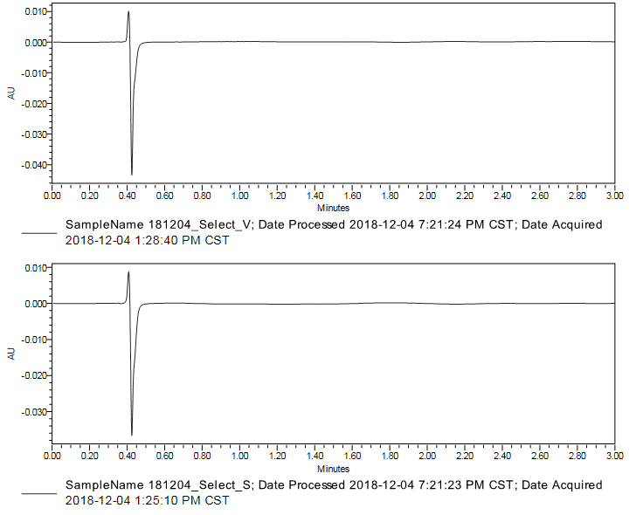
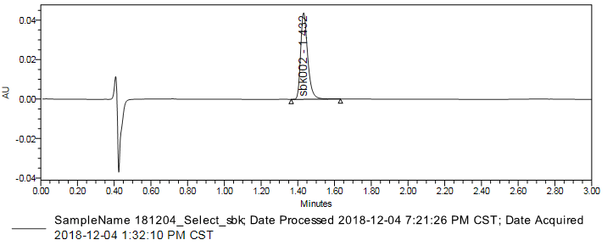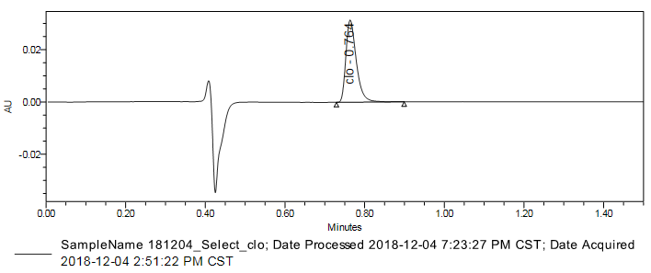
A：181204_Select_V
B：181204_Select_S
D：181204_Select_clo
C：181204_Select_sbk
Figure 1 Specificity
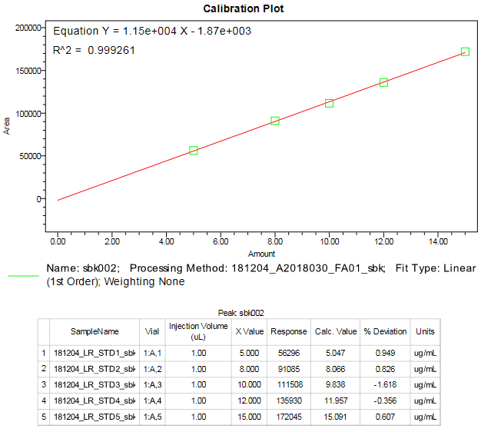
A：2018-12-04(sbk002)
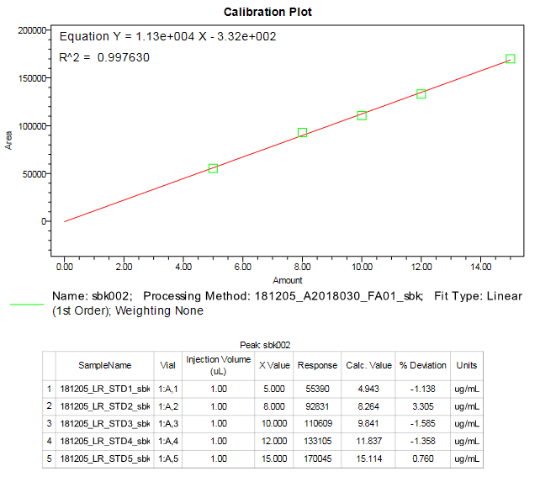
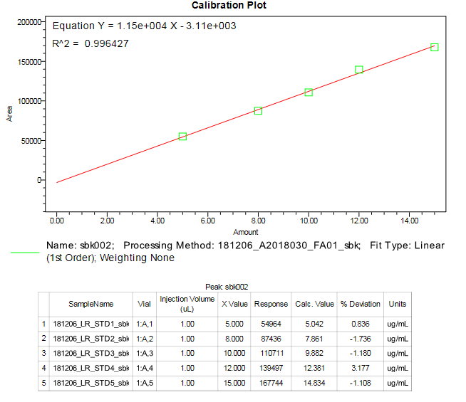
B：2018-12-05(sbk002)
B：2018-12-05(sbk)
C：2018-12-06(sbk002)
Figure 2-1 Standard Curve linear range (sbk002)
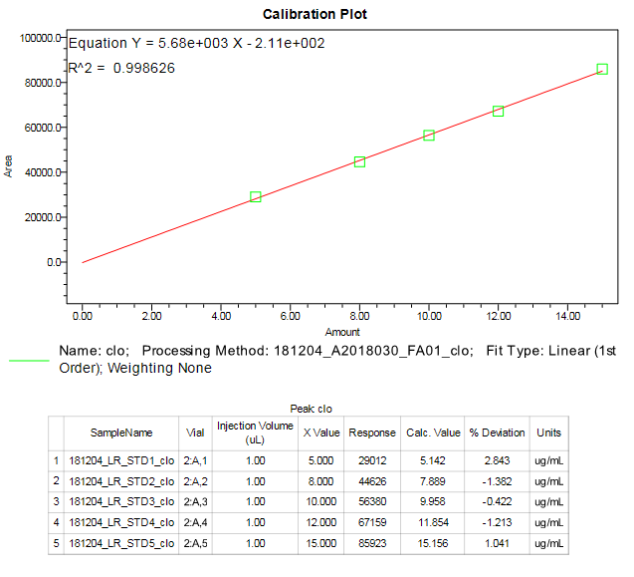
A：2018-12-04(clo)
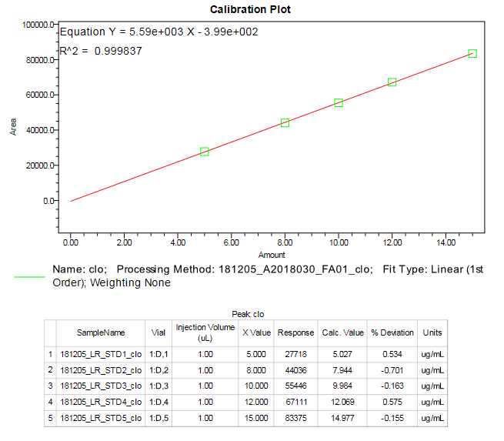
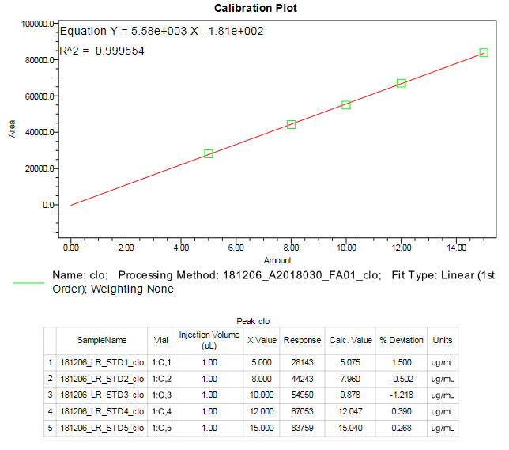
B：2018-12-05(clo)
B：2018-12-05(clo)
C：2018-12-06(clo)
Fig. 2-2 Standard Curve linear range (clo)
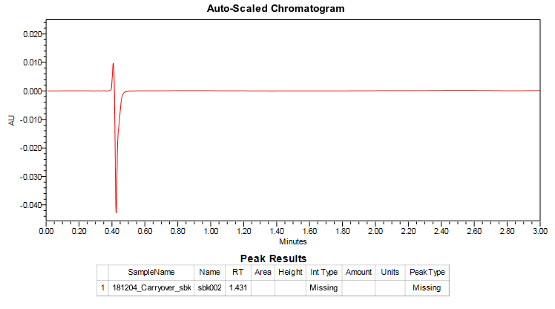
Figure 3-1 Carry-over (sbk002)

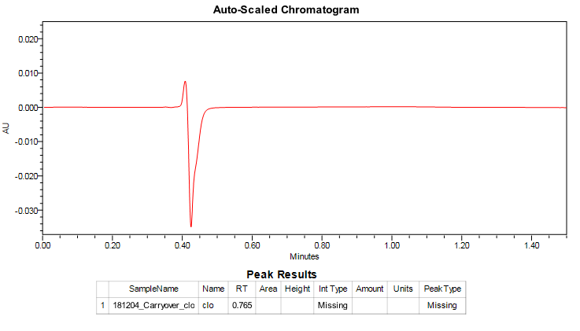
181204_Carryover_clo
Figure 3-2 Carry-over (clo)

